D-311 Unit 8: Basic Initial Attack Aircraft

Objectives:
- Identify and discuss characteristics of common tactical aircraft.
- Match common tactical missions with the appropriate aircraft
- Identify and discuss what a Safecom is and how they are used.
- Identify methods of flight following

Unit at a Glance:
Topics | Method | Duration
Objectives | Presentation | 5 Minutes
Flight Mission | Presentation / Group Discussion | 10 Minutes
Flight Types | Presentation / Group Discussion | 20 Minutes
Aerial Supervision | Presentation / Group Discussion | 20 Minutes
Flight Following | Presentation / Group Discussion | 15 Minutes
Aircraft Dispatch From | Presentation | 5 Minutes
Aviation Mishap | Presentation | 15 Minutes
Special Use Airspace | Presentation | 20 Minutes
Safecom | Presentation | 10 Minutes
Total Unit Duration |  | Total 120

Unit 8 Basic Initial Attack Aircraft Materials:
- Computer
- Unit 8 Instructor Guide
- Unit 8 PowerPoint
- Websites to show:
- Automated Flight Following (AFF) - https://www.aff.gov/
- NWCG Aircraft Dispatch Form - chrome-extension://efaidnbmnnnibpcajpcglclefindmkaj/https://gacc.nifc.gov/gbcc/logistics/aviation-docs/nwcgPms250.pdf
- Aviation Mishap Response Guide - https://www.nwcg.gov/6mfs/aviation/nwcg-aviation-mishap-response-guide-and-checklist-pms-503
- AirNAV - https://www.airnav.com/
- Safecom Website - https://www.safecom.gov/

Classroom:
- Ability to display images and video on large screen.
- White board or easel access with markers for group discussions.

Slide 1
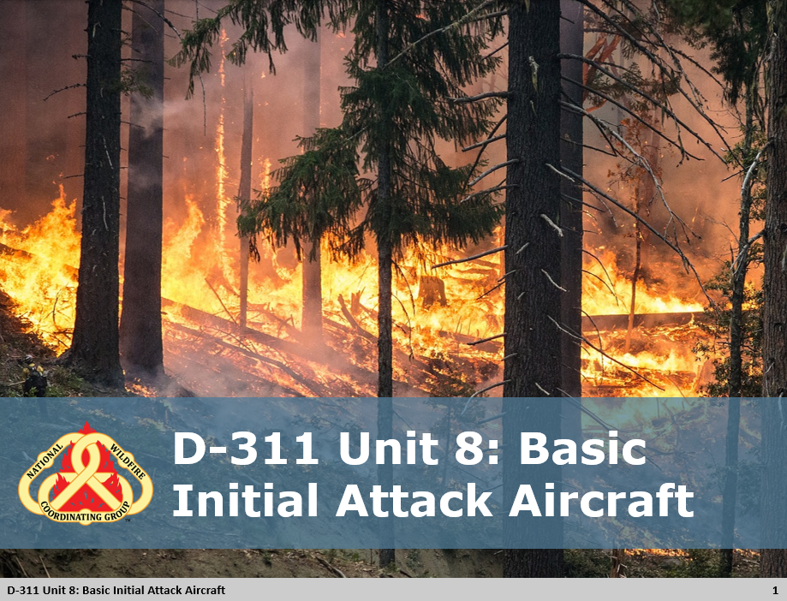

 Unit 8: Basic Initial Attack Aircraft

Slide 2
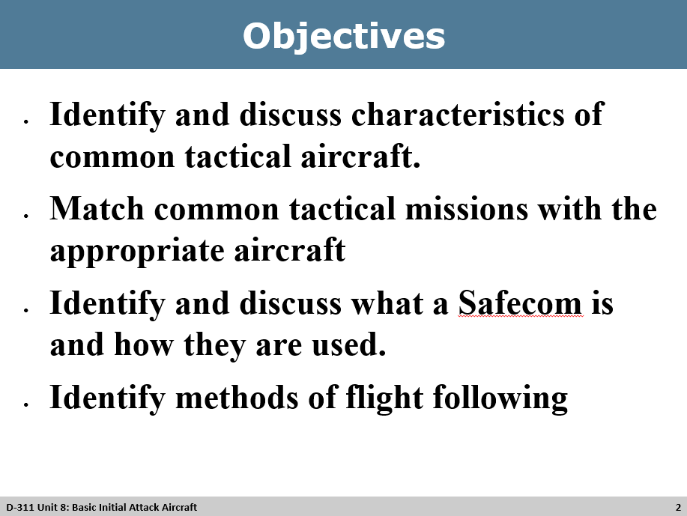
Review Unit Objectives
- Refer the participants to the objectives as listed in the PowerPoint slide. Allow time for the participants to review.
- Present course goal and objectives

Slide 3
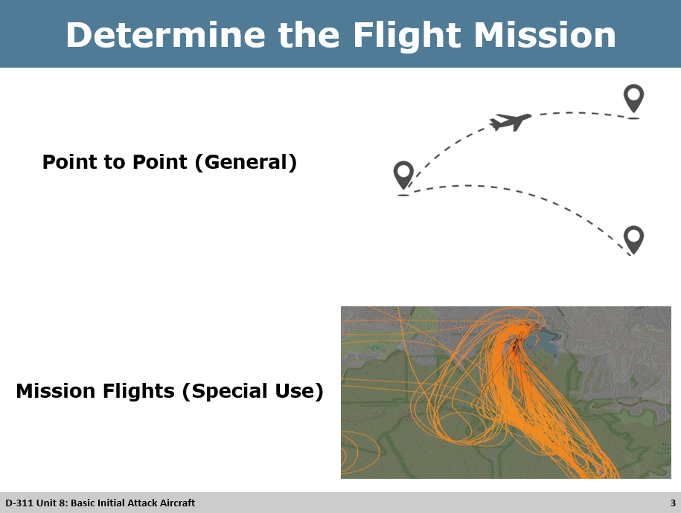
Determine the Flight Mission
Flight Categories
- All flights can be divided into two categories
  - Point to point (General Use)
  - Mission Flights (Special Use)
- Point to Point (General Use)
  - Flights typically originate at one developed airport or permanent helibase with the direct flight to another developed airport or permanent helibase.
  - Flights conducted higher than 500 feet Above Ground Level (AGL)
- Mission Flights (Special Use)
  - Flights not meeting the definition of Point – to Point flights.
  - Aircraft operations associated with initial attack of wildland fires, support of large incidents, and resources management.
  - Mission flight requires work to be performed in the air or through a combination of ground and aerial operation.
  - Flights conducted within 500 feet of AGL.
  - Individuals are required to wear Protective Personal Equipment (PPE)

Slide 4
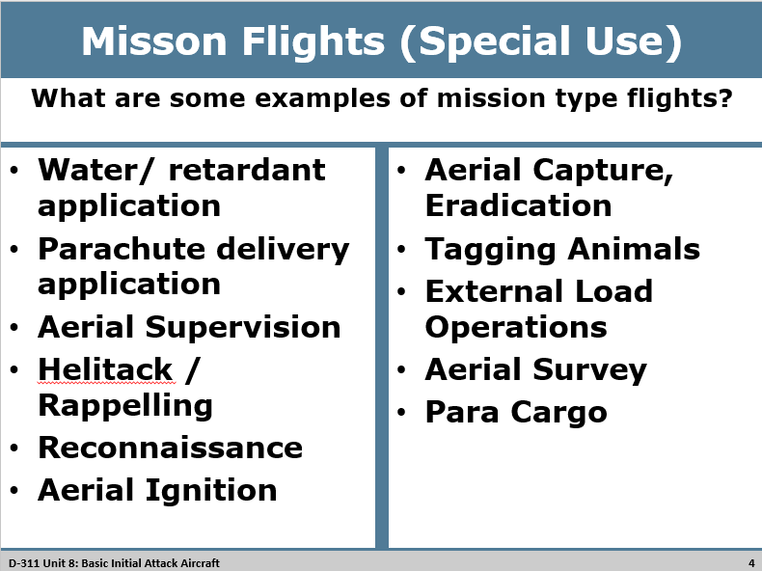

Group Discussion
What are some examples of mission type flights?

    - Water/retardant application
    - Parachute delivery application
    - Aerial supervision
    - Heli tack / Rappelling
    - Reconnaissance
    - Aerial Ignition
    - Aerial Capture, Eradication
    - Tagging Animal
    - External load operation
    - Aerial Survey
    - Para Cargo

Slide 5
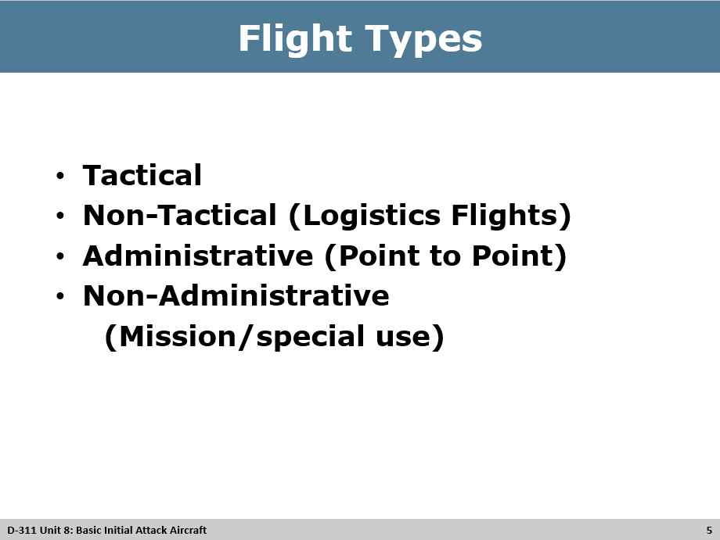
Flight Types
- Tactical
- Non-Tactical (Logistical Flights)
- Administrative (Point to Point)
- Non-Administrative (Mission/Special Use)

Slide 6
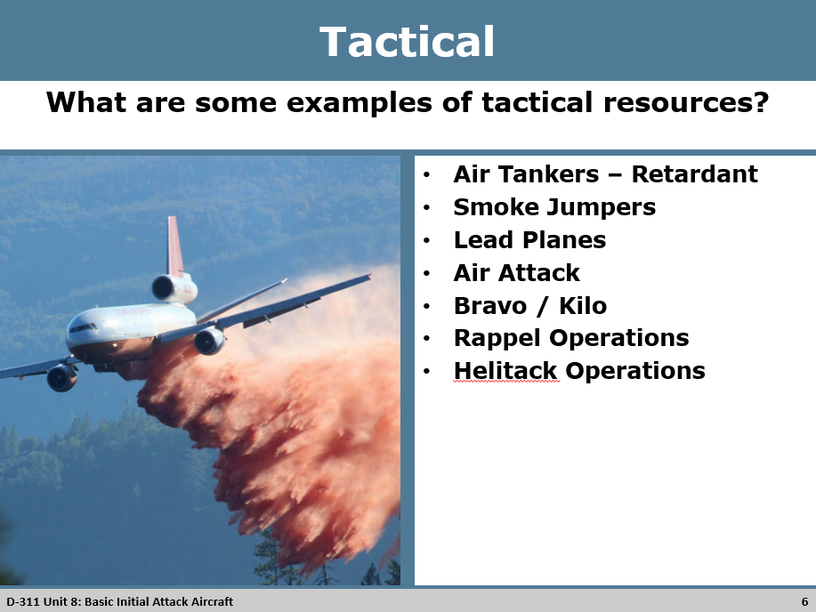
Tactical
Any aircraft operations/activity that results in the suppression of wildland fire.
Group Discussion
What are some examples of tactical resources?

- Retardant
- Smoke Jumpers
- Lead Planes / Air Service
- Module / Air Attack
- Rappel/Helitack Operations

NWCG Taskbook Positions:
- AITS – Air Tactical Supervisor
- ASGS – Air Support Group Supervisor
- ATGS – Air Tactical Group Supervisor
- HMGB – Helicopter Manager
- SEMG – Signle Engine Airtanker Manager
- UASP – Unmanned Aircraft System Pilot

What are the various levels that you can order resources from?
- Resources: National / GACC / Local

Slide 7
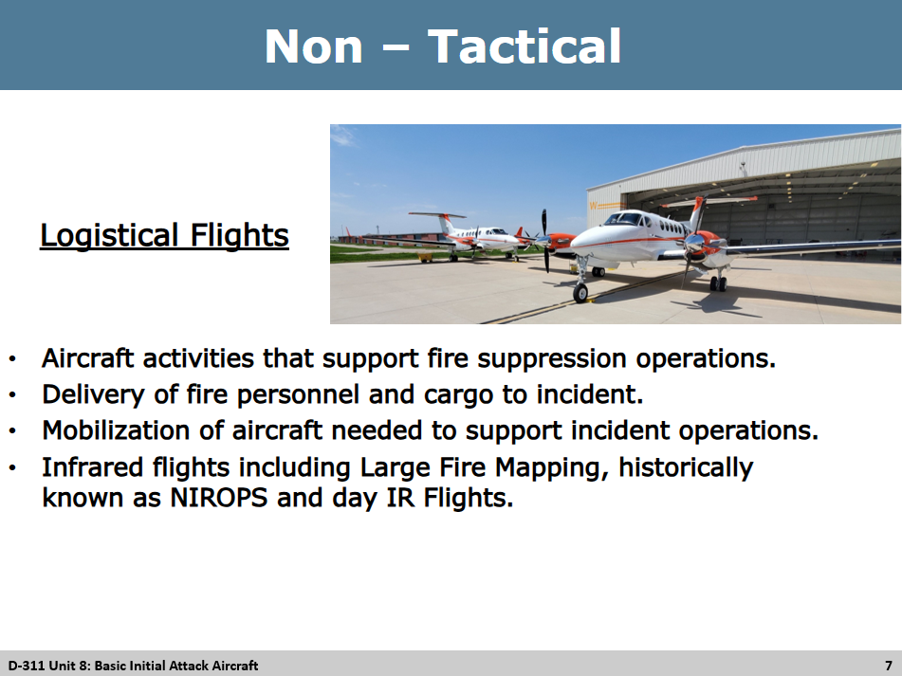
Non – Tactical (Logistical Flights)
- Any aircraft activities that support fire suppression operation
- Delivery of fire personnel and cargo to incident
- Mobilization of aircraft needed to support incident operations.
- Infrared flights: including Large Fire Mapping, historically known as NIROPS and day IR Flights.

Slide 8
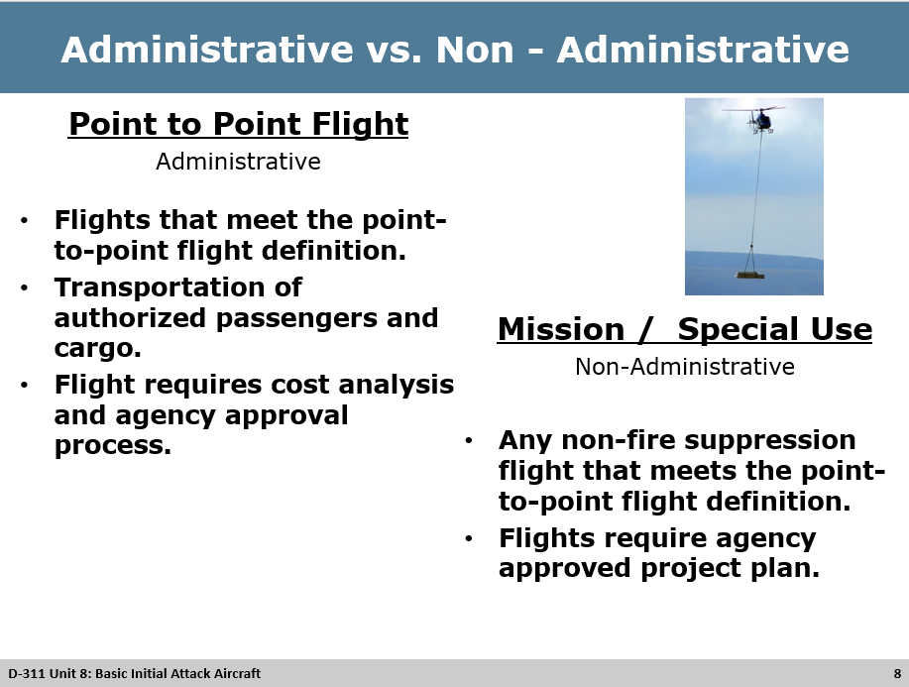
Administrative (Point to Point Flights)
- Any flights that meet the point-to-point flight definition
- Transportation of authorized passengers and cargo
- Flight requires cost analysis and agency approval process.

Examples:
- Single day Meeting – Flight from Oregon to Idaho with more than 2 people. Cost analysis of driving vs. flying. (Using R6 Smokey Bear Plane (Gov. owned with gov pilot) saves travel time, multiple day travel, perdiem, salary.
- Flying in supplies to Red’s Horse Ranch (Minam Lodge) – Forest Service owned horse ranch in the Eagle Cap Wilderness. Cost Analysis of flying (15 min flight) vs. mule packing 8.5 miles in on a moderartly challenging route one way.
- Flying a boost load of smoke jumpers from one airport to another.
Non – Administrative (Mission / Special Use)
- Any non-fire suppression flight that meets the point-to-point flight definition.
- Flights require an agency approved Project Plan.

Examples: Wildlife, Range and Forest Health Surveys, Repeater Missions, Staffing Lookout.

Slide 9
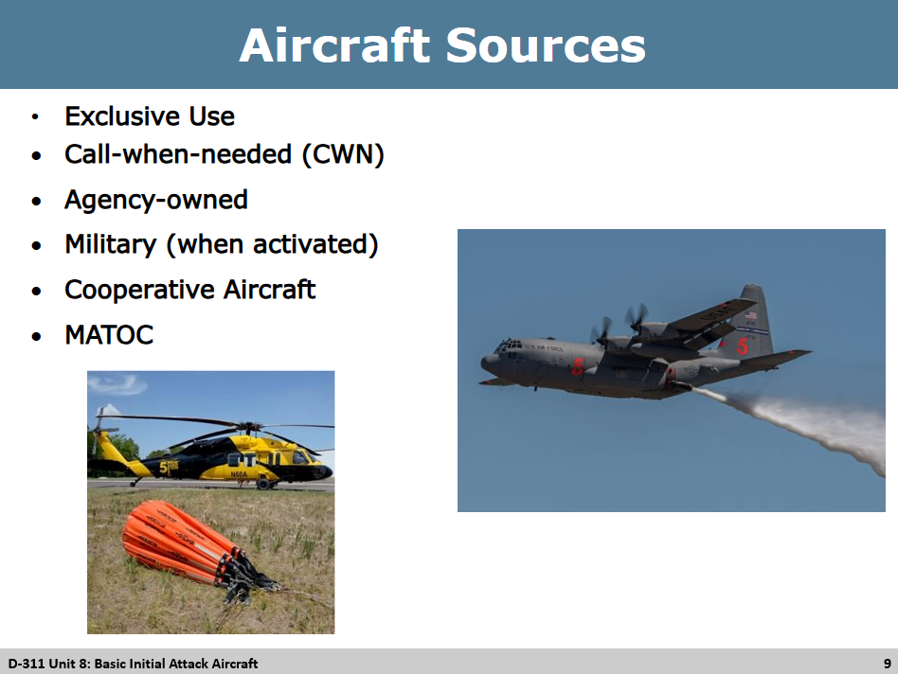
Aircraft Sources
- Exclusive use (Awarded agency contract)
- Call-when-needed (CWN) – hired based on need / work to release first on incidents due to cost.
- Agency-owned
- Military (when activated)
- Cooperative Aircraft
- MATOC – Multiple Award Task Order Contract – The government awards work to multiple vendors instead of just one.

Slide 10
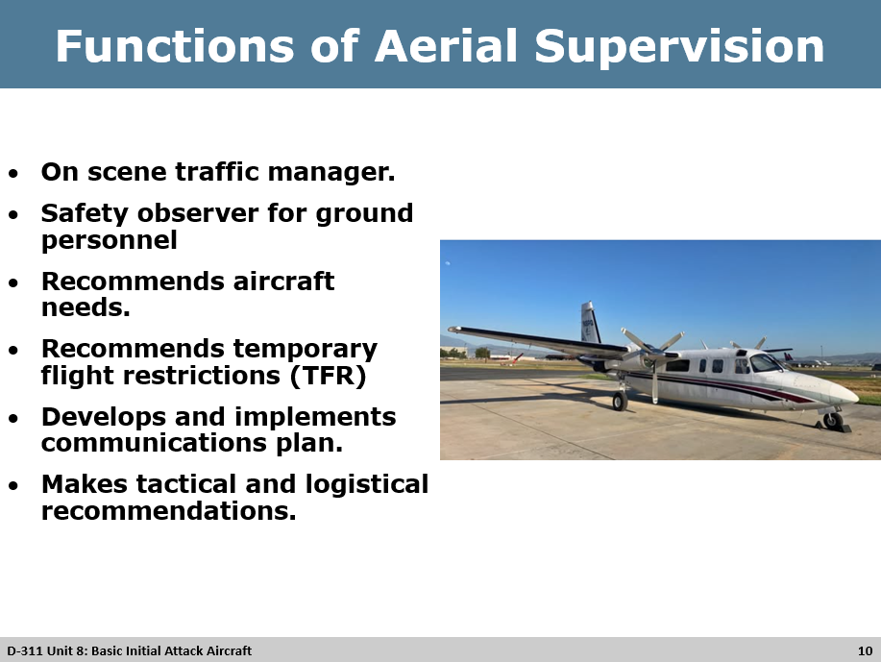
Functions of Aerial Supervision
- On scene traffic manager.
- Safety observer for ground personnel
- Recommends aircraft needs.
- Recommends temporary flight restrictions (TFR)
- Develops and implements communications plan.
- Makes tactical and logistical recommendations.

Slide 11
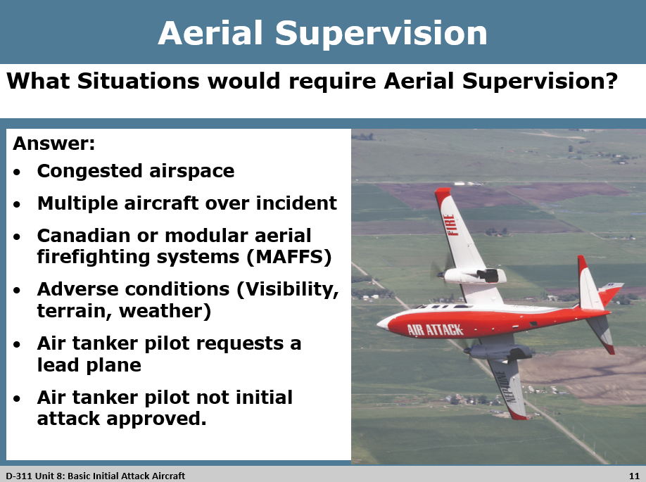
Aerial Supervision
Group Discussion
What situations require Aerial Supervision?
- Congested airspace
- Multiple aircraft over incident
- Canadian or modular aerial firefighting systems (MAFFS)
- Adverse conditions (Visibility, terrain, weather)
- Air tanker pilot requests a lead plane
- Air tanker pilot not initial attack approved.
- Lead plane / air attack requirements and guidelines from
  - This form is to ensure effective supervision and timely mission accomplishments of all aircraft over an incident.

Slide 12
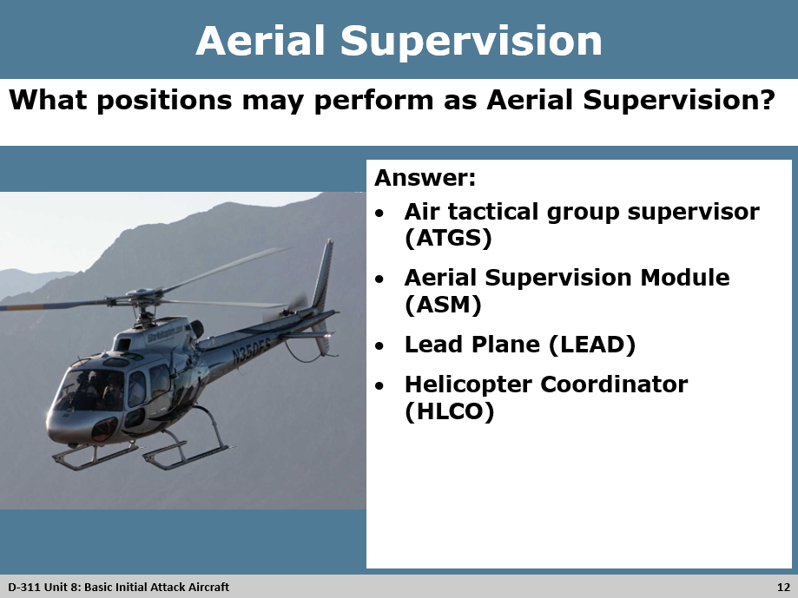
Aerial Supervision
Group Discussion
What Positions may perform as Aerial Supervision?

- Air tactical group supervisor (ATGS)
- Aerial Supervision Module (ASM)
- Lead Plane (LEAD)
- Helicopter Coordinator (HLCO)

Slide 13
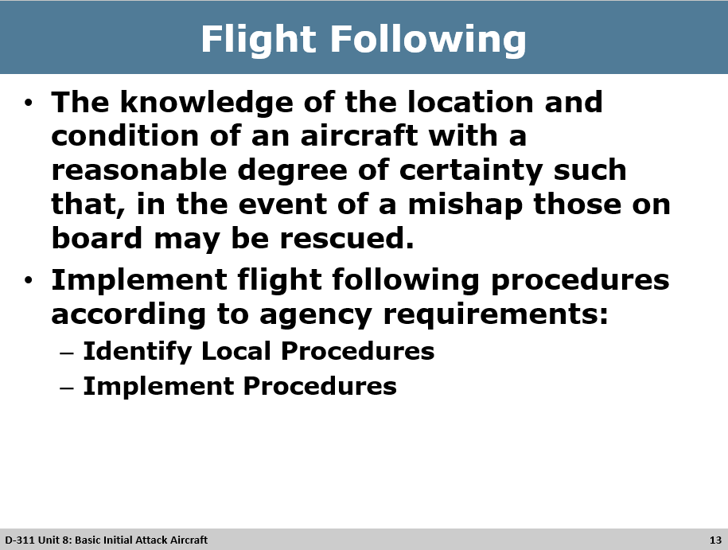
Flight Following
The knowledge of the location and condition of an aircraft with a reasonable degree of certainty such that, in the event of a mishap those on board may be rescued.
- Implement flight following procedures according to agency requirements.
  - Identify local procedures.
  - Implement procedures.

Slide 14
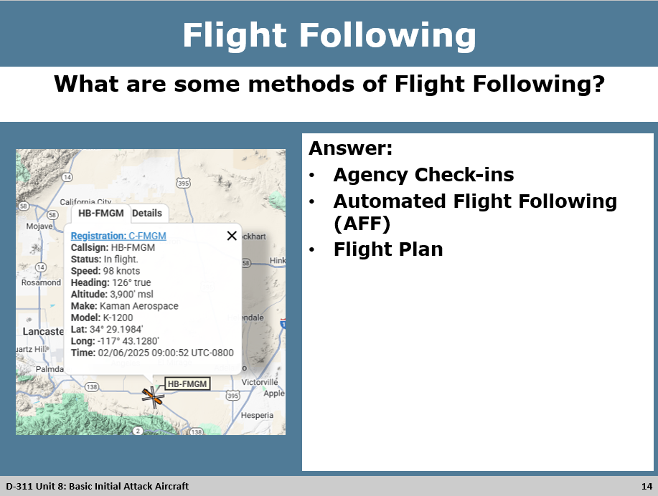
Flight Following

Group Discussion

What are some methods of Flight Following?

- Agency check ins
- Automated flight following
- Flight plan

Notes:
- 15 minute check – ins unless in Alaska which is 30 minute check-ins.
- MAFFS Modular Airborne Fire Fighting System – Will have AFF
- National Guard – Will have their own flight following set up. Make sure you are communicating with the correct personal when the National Guard is activated and flying in the area.

Slide 15
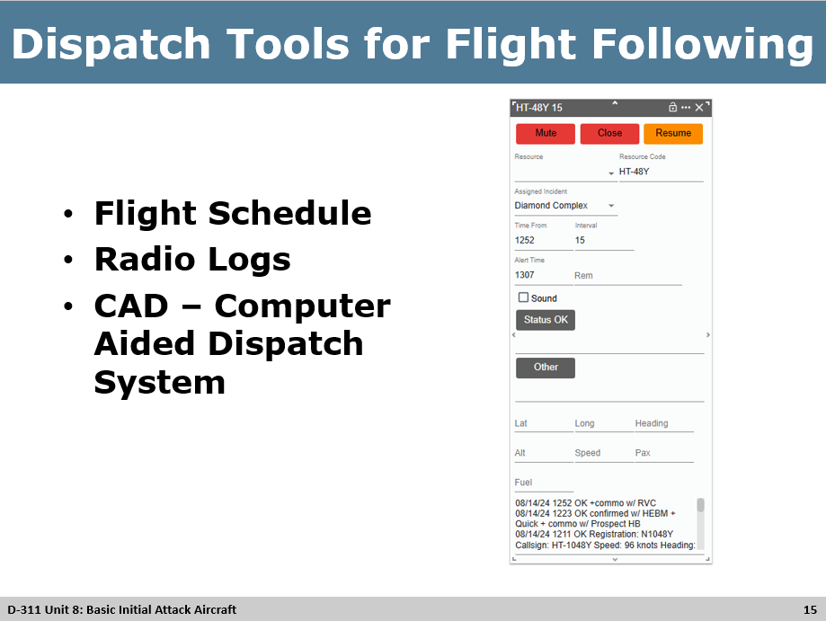
Dispatch Tools for Flight Following
- Flight Schedule
- Radio Logs
- CAD – Computer aided dispatch system

Slide 16
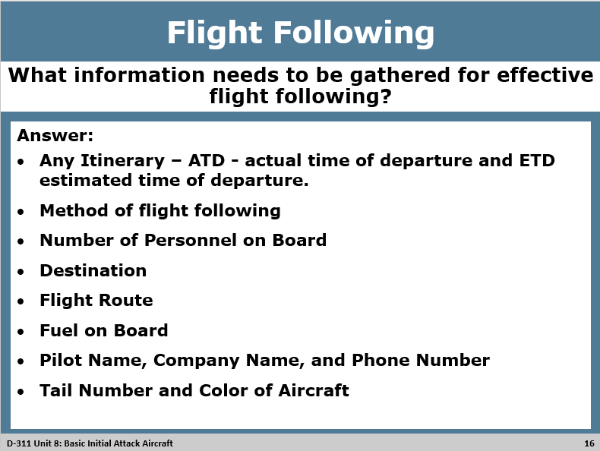
Flight Following

Group Discussion
What information needs to be gathered for effective flight following?
- Any Itinerary – ATD - actual time of departure and ETD estimated time of departure.
- Method of flight following
- Number of Personnel on Board
- Destination
- Flight Route
- Fuel on Board
- Pilot Name, Company Name, and Phone Number
- Tail Number and Color of Aircraft
Notes:
- Flight Following radio vitals: If you copied you do not need to repeat due to taking up air time. If you did not copy ask to repeat and copy back.
- Be sure to have a final confirmation when closing out flight following.
- FS Airguard is different than the Military / Civilian Airguard

Slide 17
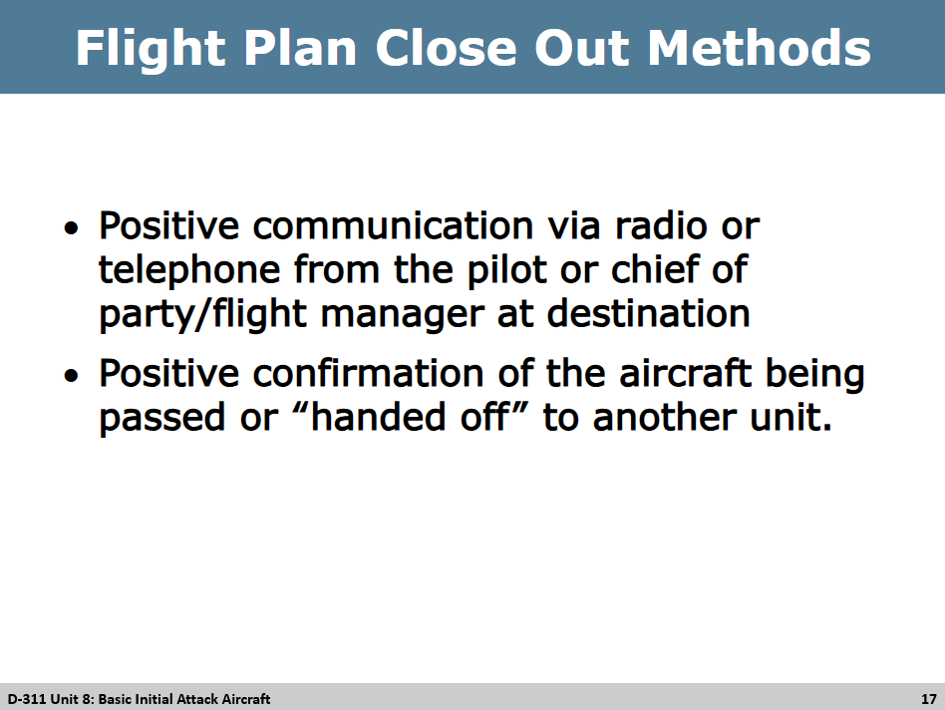
Flight Plan Close Out Methods
- Positive communication via radio or telephone from the pilot or chief of party/flight manager at destination
- Positive confirmation of the aircraft being passed or “handed off” to another unit.

Slide 18

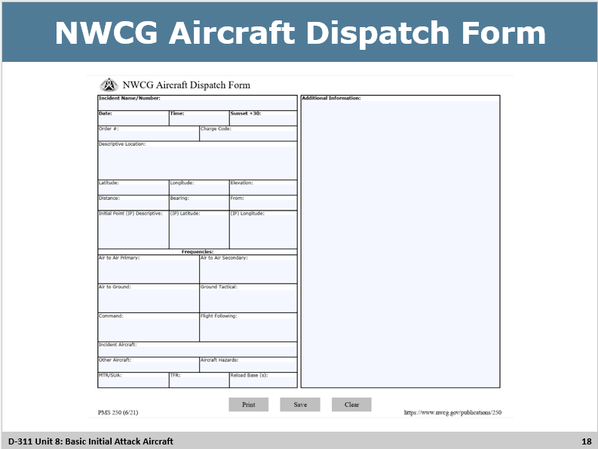
NWCG Aircraft Dispatch Form
- When filling out an Aircraft dispatch form always use Degrees DECIMAL minutes.
- Before attaching / sending out an Aircraft dispatch from make sure you have “FLATTENED PDF”. This merges the PDF into a single static layer, making the document un-editable and ensuring consistent printing and display. This ensures when it is sent to multiple location and multiple people there is less human error and numbers are not changed.
- Other names: TARO (Tactical Aviation Resource Order) / Knee Board (Pilots used to put on their need for notes)

Fun Facts:
- NM – Nautical Mile – It is used to travel through water. 1 NM is equal to 1 minute latitude. 1 NM is 1.1 land mile. Nautical Mile has been used in the United States since July 1, 1954.

Slide 19

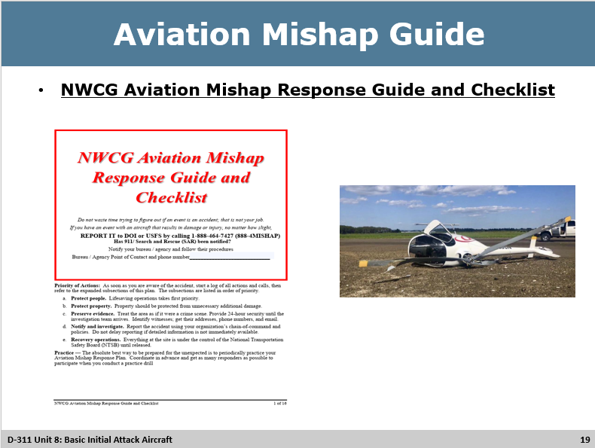
 Aviation Mishap Guide
Overdue and Missing Aircraft information is located on page 10 of the NWCG Aviation Mishap Guide/PMS503
https://www.nwcg.gov/6mfs/aviation/nwcg-aviation-mishap-response-guide-and-checklist-pms-503
Notes:
- Always know where the Mishap Guide is.
- Should be a yearly update:
  - Phone numbers
  - Frequencies
  - Hospital Tramua Level and direct numbers

Slide 20
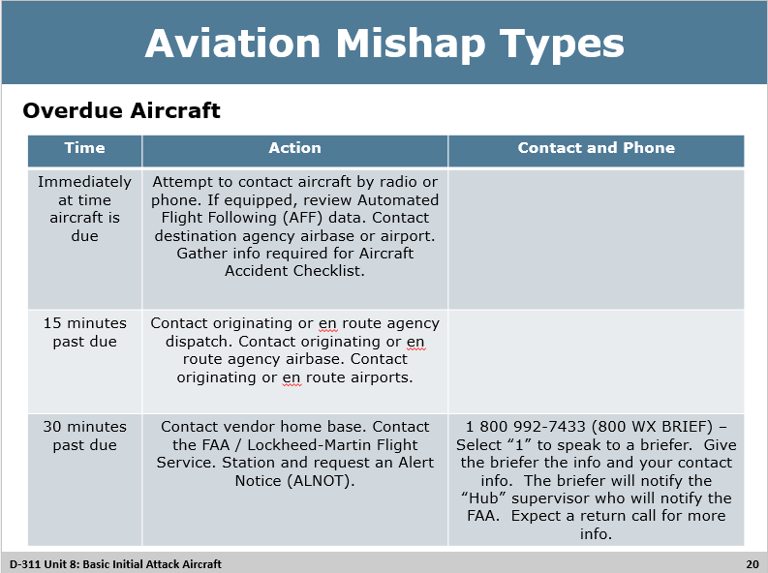
Aviation Mishap Types
Overdue aircraft
- An Aircraft is considered “overdue” when it fails to arrive within 30 min past ETA and cannot be located.

Actions:
- Notifications
  - Floor Supervisor
  - Floor Supervisor will start the notication tree.

Slide 21
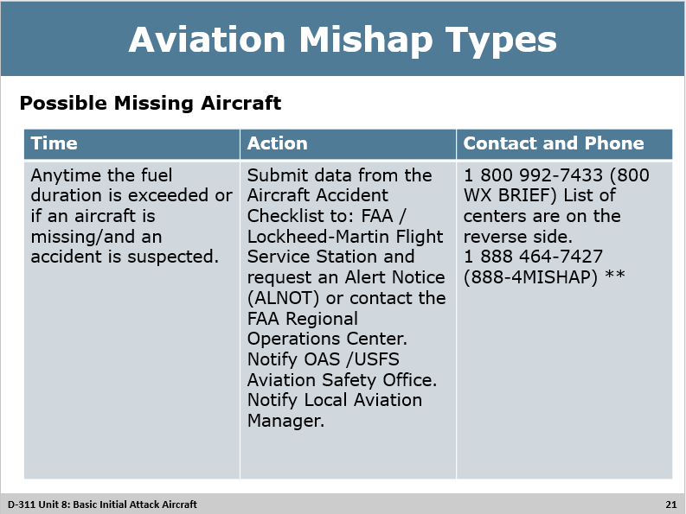
Aviation Mishap Types
Possible Missing Aircraft
  - An aircraft is considered “missing” when it has been reported to the FAA as being “overdue” and the FAA has completed an administrative search for the aircraft without success.
  - The aircraft is OFFICALLY missing when fuel duration, as reported on the flight request or on the FAA flight plan has been exceeded and the aircraft location is unknown.
Actions:
- Notifications
  - Floor Supervisor
  - Floor Supervisor will start the notication tree.

Slide 22
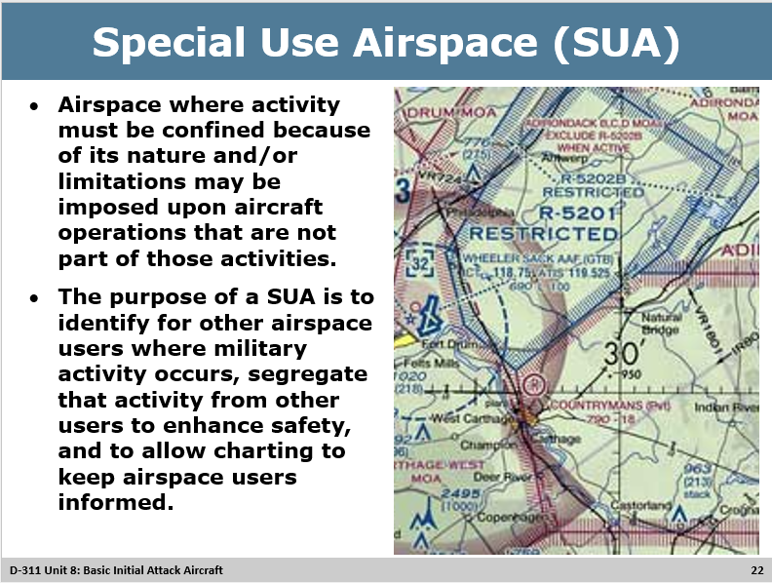
Special Use Airspace (SUA)
- Airspace where activity must be confined because of its nature and/or limitations may be imposed upon aircraft operations that are not part of those activities.
- The purpose of a SUA is to identify for other airspace users where military activity occurs, segregate that activity from other users to enhance safety, and to allow charting to keep airspace users informed.
- Deactivation of special use airspace (SUA) (Touch it and know how to find it)
- Aeronautical Charts are measured by Nautical Miles which is equal to 1.1 land mile vs a Land map which is measured by 1 mile.
Special Use Airspace - FAA
https://www.faa.gov/air_traffic/publications/atpubs/aim_html/chap3_section_4.html

Slide 23
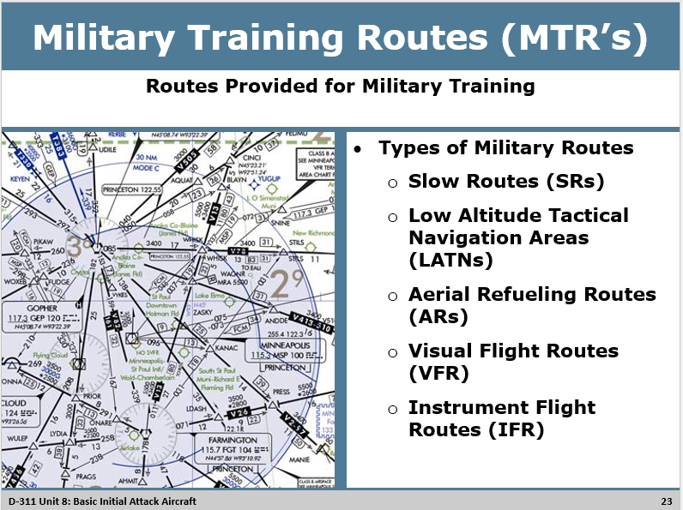
Military Training Routes (MTR’s)
- Routes provided for military training.
- Types of Military Routes
  - Slow Routes (SRs)
  - Low Altitude Tactical Navigation Areas (LATNs)
  - Aerial Refuling Routes (ARs)
  - Visual Flight Routes (VFR)
  - Instrument Flight Routes (IFR)

Slide 24
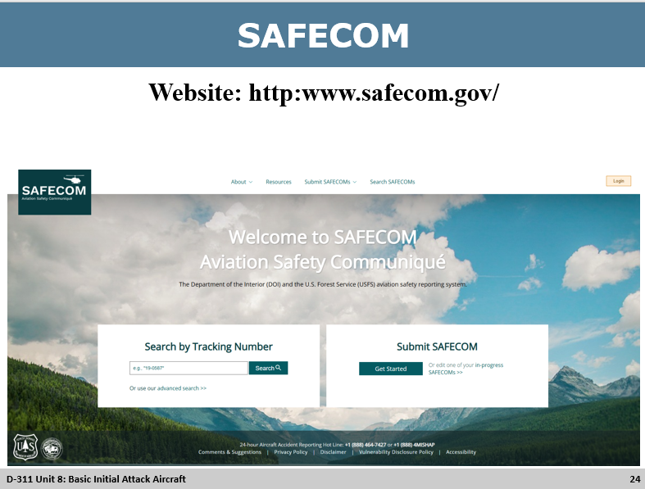
SAFECOM
- Incident/hazard/maintenance deficiency reporting
- The department of the interior and USDA Forest Service have adopted a common incident / hazard reporting form called the SAFECOM.
Objectives of SAFECOM
- The Aviation Safety Communiqué (SAFECOM) should be used to report any condition, observation, act, maintenance problem, or circumstance with personnel or the aircraft that has the potential to cause an aviation-related mishap. SAFECOMS are a tool used to identify, document, track, and correct safety-related issues.
- Instructions for completion of SAFECOM – Overview
Website: http://www.safecom.gov/

Slide 25
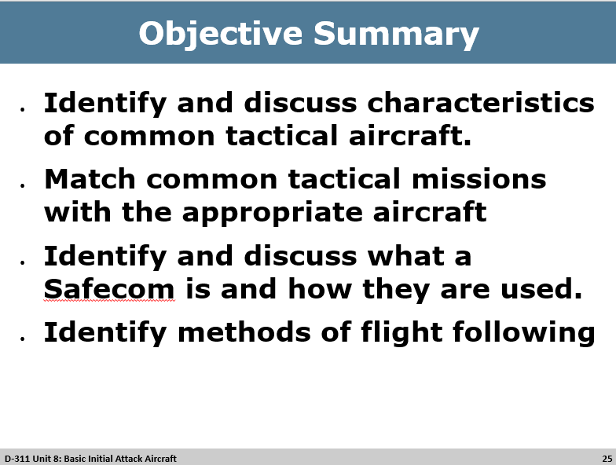
Objective Summary

